Call for Participants:
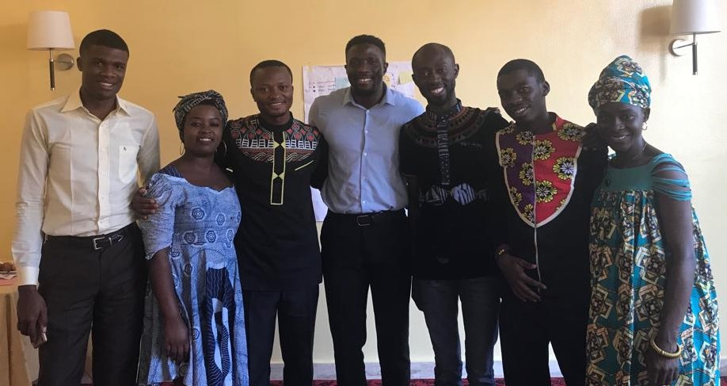
Commonwealth Technical Assistance Workshop: Women in Preventing and Countering Violent Extremism
- – 14 June 2019, Douala, Cameroon
The Commonwealth Secretariat is seeking applicants to participate in a Commonwealth Technical Assistance Workshop entitled ‘Cameroon: Participation of Women in Preventing and Countering Violent Extremism’.
This 3-day workshop seeks to train Cameroonian women working in Civil Society Organisations with a role to play in building peace and preventing violent extremism and terrorism. The topics that will be covered in the training are:
- Understanding the ways that women may be involved with or affected by violent extremism.
- Understanding the structural, social, political, ideological and personal drivers of violent extremism in Cameroon,
- Understanding how gender affects violent extremism, including identifying the vulnerabilities and the resiliencies of men and women.
- Identifying how we can prevent violent extremism in Cameroon, including looking at practices from other countries.
- Identifying how we can support women who have been involved with violent extremism to reintegrate into the community.
- identifying opportunities to more effectively involve women in preventing violent extremism in Cameroon.

The workshop will be delivered by the Commonwealth Secretariat and the International Civil Society Action Network for Women’s Rights, Peace and Security (ICAN). Representatives of the Government of the Republic of Cameroon will also be taking part in the workshop.
We invite applications from women working in civil society organisations that play a role in preventing violent extremism and peacebuilding, especially in areas of Cameroon that are affected by conflict. Applications from males working to support women’s peace and security in Cameroon will also be considered.
Applicants from all regions of Cameroon are welcome to apply. Applicants may receive priority if they are able to demonstrate that they are working to serve the people of conflict-affected regions of Cameroon. Fluency in English and / or French is essential.
Travel, meal and accommodation costs will be covered for successful applicants who ordinarily live outside of Douala. Successful applicants who live in Douala will receive lunch and tea breaks on workshop days.
Know someone who would be perfect for this programme? Please feel free to circulate this call among your networks, we look forward to receiving applications from a diverse range of people.
Application forms must be completed and submitted by 5pm GMT on Monday 27 May 2019. Incomplete applicants may not be successful.
All successful applicants will be contacted by Friday 31 May 2019. If you do not receive a notification that your application has been successful, we are not able to accept you at the workshop.

Administrative Arrangements
The workshop can accommodate 30 participants. A minimum of 26 participants are to be from civil society organisations and 4 participants are Government representatives that can guide the participants’ future engagement with the Government and provide practical advice about how participants from civil society can effectively contribute to government decision making on P/CVE and peacebuilding within Cameroon.
WORKSHOP VENUE
The training course will be held at a hotel in Douala, Cameroon.
ACCOMMODATION & MEALS
- Accommodation: The Secretariat will arrange and provide accommodation on Bed & Breakfast basis for participants that normally live outside Douala (residential participants). Accommodation will be at the hotel where the workshop is being held or at a hotel nearby.

Participants that normally live in Douala (non-residential participants) are expected to stay at their own accommodation. The Secretariat cannot reimburse for daily travel.

- Additional Expenses: All additional expense such as luggage costs, extra meals, telephone, laundry, room service charges and gratuity, alcoholic and non-alcoholic beverages, and all costs for room services, printing and faxing will be at the participant’s own expense. The hotel has been instructed to invoice participants for chargeable services/items used/consumed, on or prior to departure from the hotel. All accounts must be settled in advance of departure.
MEALS AND INCIDENTALS
- Meals
  - Lunch and tea breaks will be provided for all participants (residential and non-residential) on workshop days
  - Residential participants will be provided with breakfast at the hotel, and will receive a cash allowance for dinner costs.

- Incidentals: Residential participants will be provided with a small allowance for incidentals.
Rate: The rate will be set in accordance with the Commonwealth Secretariat Travel Policy.

FINANCIAL AND TRAVEL ARRANGEMENTS
Residential participants will be reimbursed for ground travel, if they provide receipts and the travel is according to the following list below. Any travel which is not within the limits below must be approved in advance with the Secretariat.
- Bus, Rail or car to and from your home to the nearest inter-city bus/train station.
- Bus or Train travel between the two cities.
- Air travel will not be reimbursed unless it is agreed in advance with Ms Sherburn.
- Travel for participants living in Douala (non-residential participants): No travel reimbursement will be provided to participants that ordinarily live in Douala.

Participant Application Form
Commonwealth Technical Assistance Workshop: Women in Cameroon Preventing and Countering Violent Extremism

Submit completed application form with all supporting documents to: cve@commonwealth.int before 5pm GMT on Friday 17 May 2019. Applications must include:
- Recent CV
- Scan or clear photo of the bio page of your passport or another form of photo identification.
- Completed application form
Please complete this document electronically, handwritten applications will not be accepted
- PARTICIPANT ELIGIBILITY

Applicants are subject to eligibility criteria; please tick the following statements as they apply to you.

I am aged over 18
I am a citizen of Cameroon or currently reside in Cameroon.
I am committed to upholding the Commonwealth values, including the value of good governance and equality for all.
I am able to speak fluently in English or French – the working languages of the training course
I confirm that I am medically fit, both physically and mentally, to travel and participate in the training course
I am able to evidence voluntary or professional experience on peace building and CVE issues
I am willing to share case studies and highlight relevant aspects of my work
I am willing to be an active participant and commit to spreading the values and outcomes of the workshop.

- GENERAL INFORMATION

Name and Surname:
Preferred first name
Email:
Telephone/s:
Address:
Citizenship/s Held:
Working language/s:
Birth Date:
Identified Gender:
Current Occupation | ☐ Student  ☐ Employed  ☐ Self-employed  ☐ Other: If other, please specify here
Emergency Contact Details | Name | Insert name
 | Relationship | Insert relationship
 | Contact Number | Insert telephone number
I am happy to be contacted by WhatsApp | ☐ Yes ☐ No
Throughout the workshop, staff or consultants of the Commonwealth Secretariat will be taking photographs and film to document the programme. I am happy for the Commonwealth Secretariat, or its partnering organisations, to use any photographs and film that features me for publicity resources and media outputs, such as press releases, reports and on social media platforms (Twitter and Facebook).
Any special diet or health conditions or additional support needs, including dietary, disability, mental health, allergies etc: (we may request more detailed disclosure in confidence)

APPLICANT QUESTIONNAIRE
- Explain your motivation for participating in this training (in under 300 words)
Enter text
- Please tell us how you will use this experience and learning to help make change happen in your community in the future (in under 300 words).
Enter text
- Any further comments or information you wish to share.
Enter text
I have read and understood the administrative arrangements | ☐ Yes ☐ No | Participant Signature

SUPPORTING DOCUMENTATION

Please ensure that you attach (in PDF or Word form):
- Recent CV
- Scan or clear photo of the bio page of your passport you will be travelling with

SENDING YOUR APPLICATION FORM
- Complete the application form fully
- Attach it to ONE e-mail with the subject heading: ‘[Your Name] Cameroon: Women in CVE Workshop Application’
- Attach your supporting document(s)
- Email to cve@commonwealth.int by 5pm GMT on Monday 27 May 2019

The deadline for completed application forms is 5pm GMT on Monday 27 May 2019. Please note, all successful applicants will be contacted by Friday 31 May 2019. If you do not receive a notification that your application has been successful, we are not able to accept you at the workshop.

For further information, contact cve@commonwealth.int

